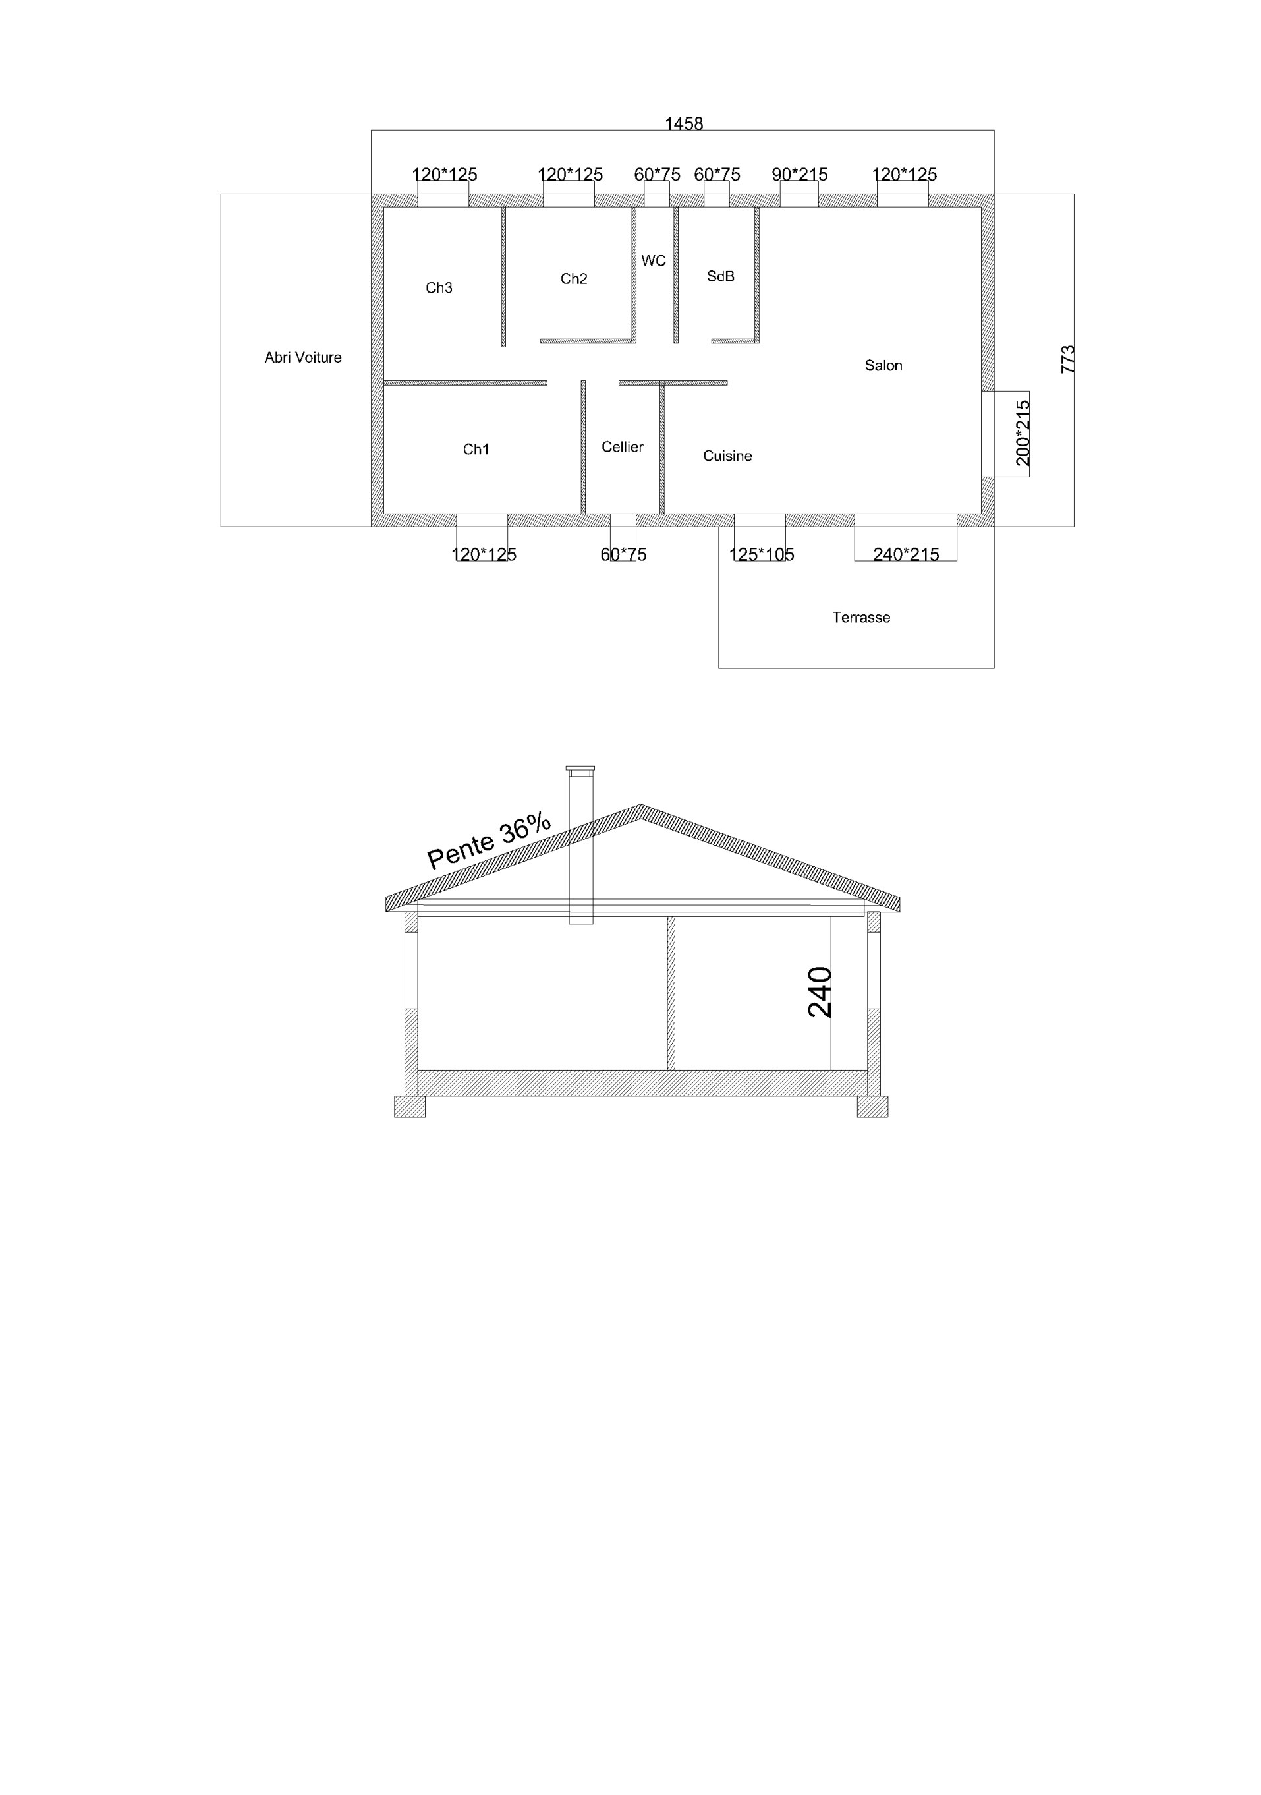

|  |  |  |  |
| --- | --- | --- | --- |
| Annexes |  |  |  |
|  | Abri voiture | 25.51 m² |  |
|  | Terrasse | 36 m² | 44.87 m² |
| Habitable |  |  |  |
|  | Ch 1 | 13.95 m² |  |
|  | Ch2 | 11.13 m² |  |
|  | Ch 3 | 9 m² |  |
|  | Cellier | 5.54 m² |  |
|  | Dégagement | 5.94 m² |  |
|  | SdB | 5.48 m² |  |
|  | Salon | 32.74 m² |  |
|  | Wc | 1.44 m² | 97.22 m² |

# Tableau des surfaces